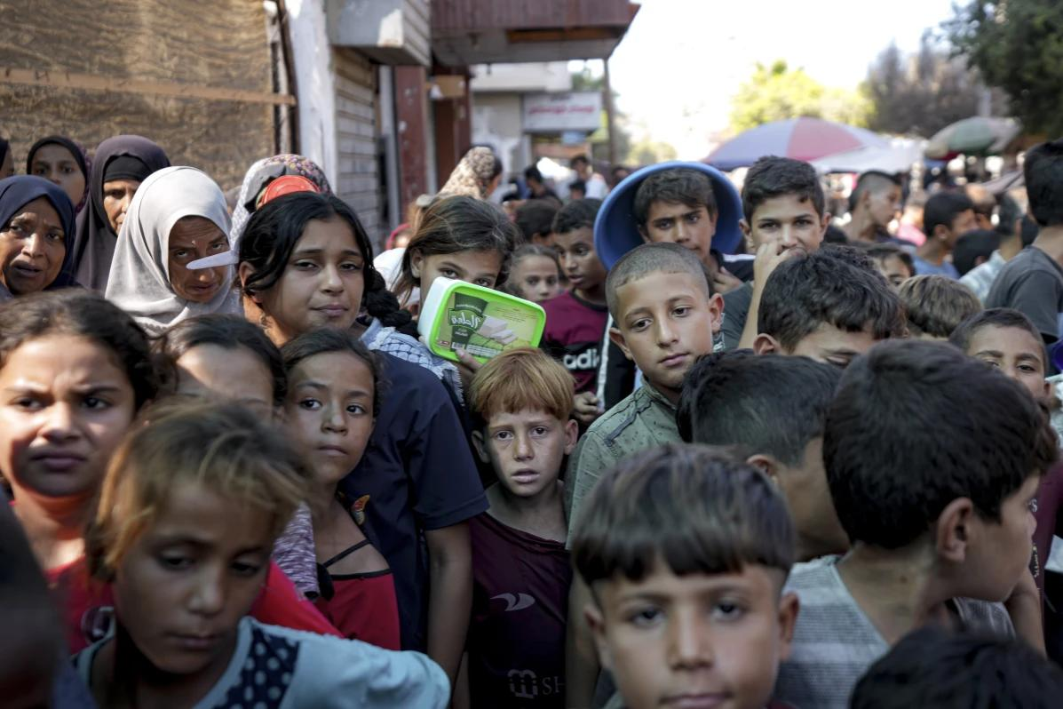

WASHINGTON (AP) — The Biden administration said Tuesday that Israel has made some good but limited progress in increasing the flow of humanitarian aid to Gaza and will not limit arms transfers to Israel as it had [threatened to a month ago](https://apnews.com/article/israel-gaza-humanitarian-aid-blinken-austin-887ae388a022215f71309ab6def12103) if the situation had not improved. Relief groups say conditions are worse than at any point [in the 13-month-old war](https://apnews.com/hub/israel-hamas-war).

Although Apple hasn't made any announcements about a TV set, Bloomberg [reported](https://www.bloomberg.com/news/newsletters/2024-11-17/how-will-president-donald-trump-s-new-tariffs-affect-apple-products-and-prices-m3lnfx64?srnd=undefined) that the tech giant is evaluating the concept. That comes as Apple is said to be exploring smart home devices like a wall-mounted tablet or an AI assistant attached to a robotic arm as it looks to expand its offerings.

Parts of the northwest are already starting to feel impacts from the storm, with strong wind gusts already observed in the Seattle area. NOAA's weather prediction centre said the storm is expected to bring heavy, wet snow to mountain ranges in the Pacific Northwest with accumulation rates of 2-3in (5-8cm) per hour and wind up to 65 mph (29mps).